PROJECT DESIGN PHASE

The Project Design Phase comes after Requirement Analysis and before Development. In this phase, the team decides how the system will be built technically and visually. While the requirement phase answers “What to build?”, the design phase answers “How to build it?”. It acts as a blueprint or architecture plan for developers so that coding becomes structured and error-free.

1. Purpose of the Design Phase
The main objectives of the Project Design Phase are:
- Convert requirements into technical solutions.
- Plan the system architecture and data flow.
- Define UI/UX layouts for users, agents, and admins.
- Identify tools, frameworks, and technologies.
- Reduce development risks and confusion.
- Ensure scalability, performance, and security planning.
For the complaint management system, this phase ensures that the complaint submission, tracking, messaging, and admin management features are properly structured before implementation.

ER-DIAGRAM:

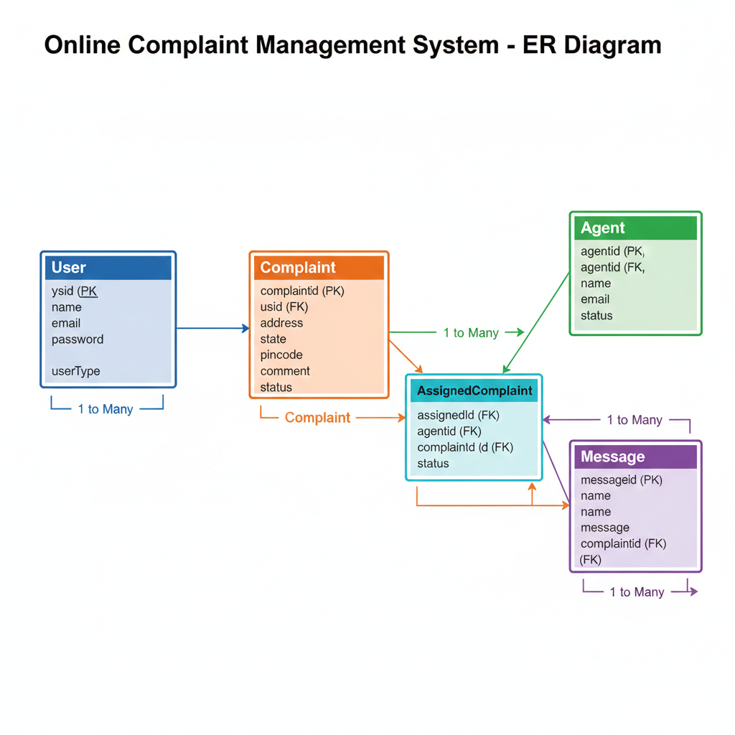

2. High-Level Design (HLD)
High-Level Design provides an overall system view without going deep into code details. It shows how major components interact with each other.
Key Components Identified:
- Frontend (Client Side) – React.js interface for users, agents, and admins.
- Backend (Server Side) – Node.js and Express.js handling APIs and business logic.
- Database – MongoDB storing user details, complaints, messages, and assignments.
- Email Service – Nodemailer or SMTP service for notifications.
- Authentication Module – Login, registration, and role management.
The HLD diagram usually includes system blocks, arrows showing data flow, and interaction paths between frontend, backend, and database.

3. Low-Level Design (LLD)
Low-Level Design focuses on detailed internal structure. It defines:
- API endpoints and request/response formats.
- Database schema and relationships.
- Function logic for complaint submission and status updates.
- Validation rules and error handling.
- Role-based access control logic.
This is the stage where developers plan exact implementation steps, such as how the login API compares encrypted passwords or how the complaint status changes from Pending → Assigned → Resolved.

4. Database Design
Database design is critical because it defines how information is stored and retrieved.
Entities Designed:
- User – name, email, password, role.
- Complaint – description, address, city, state, status.
- Assigned Complaint – agent ID, complaint ID, status.
- Message/Chat – sender name, message, complaint ID.
- OTP/Verification – email, OTP, expiration time.
Relationships:
- One user can have many complaints.
- One complaint can be assigned to one agent.
- One complaint can contain many chat messages.
ER Diagrams are prepared to visually represent these relationships and ensure database normalization.

5. User Interface (UI) Design
UI Design focuses on the look and feel of the system. The goal is to create an interface that is simple, intuitive, and visually appealing.
Planned Screens:
- Registration and Login Page.
- User Dashboard.
- Complaint Submission Form.
- Complaint Tracking Page.
- Agent Dashboard.
- Admin Management Panel.
- Chat Window.
Wireframes or mockups are created using tools like Figma or Adobe XD to visualize button placement, navigation menus, and color themes before actual coding begins.

6. User Experience (UX) Design
UX design ensures smooth interaction for all user types.
Considerations include:
- Easy navigation and minimal clicks.
- Clear status indicators for complaints.
- Instant notifications and confirmations.
- Responsive design for mobile and desktop.
- Accessibility and readability.
The aim is to reduce confusion and make the system comfortable even for first-time users.

7. API Design
APIs act as a bridge between frontend and backend. During design, endpoints are planned such as:
- /signup – Register user
- /login – Authenticate user
- /complaint/:id – Submit complaint
- /status/:id – Track complaint
- /messages – Chat messaging
- /assignedComplaints – Admin assignment
API documentation is prepared with request methods (GET, POST, PUT, DELETE), parameters, and expected responses.

8. Security Design
Security planning is essential in this phase to protect user data.
Measures include:
- Password hashing using bcrypt.
- Role-based access (User, Agent, Admin).
- Email verification or OTP.
- Secure environment variables.
- CORS and input validation.
- Protection against SQL/NoSQL injection and XSS attacks.

9. System Workflow Design
Flow diagrams or sequence diagrams are created to show step-by-step interactions, such as:
- User logs in.
- User submits complaint.
- Admin assigns agent.
- Agent updates status.
- User receives notification.
- User gives feedback.
These diagrams ensure every action and reaction in the system is clearly mapped.

10. Technology Stack Finalization
During design, the final tools and frameworks are confirmed:
- Frontend: React.js, Bootstrap/Material UI
- Backend: Node.js, Express.js
- Database: MongoDB
- Authentication: JWT / bcrypt
- Email Service: Nodemailer / SMTP
- Version Control: Git & GitHub
This avoids technology changes during development.

